Advanced Engineering Mathematics, by Erwin Kreyszig 10th. Ed.

**Problem Set 3.3**

No. 1



Homogeneous equation: 

Auxiliary equation: 

(triple root)





Set 







Replace and yp in the original equation.













General sol.: 

No. 2



Homogeneous equation: 

Auxiliary equation: 





Set 







Replaceand yp in the original equation.



















General sol.:

No. 3



Homogeneous equation: 

Auxiliary equation: 









Set 









Replaceand yp in the original equation.











General solution: 

No. 4



Homogeneous equation;





and







Set 







Replace y”’, y”, y’ and y in the original equation with and,

 

 (1)

 (2)

(1)×7+(2) 





General sol.:

No. 5



Homogeneous equation;

Auxiliary equation 



 

 (double root)

























General sol.:

No. 6



Homogeneous equation;

 

and







Set 







Replace y”’, y”, y’ and y in the original equation with and,









General sol.:

No. 7



Homogeneous equation;

 

(triple root)







Set 







Replace y”’, y”, y’ and y in the original equation with and,

 



 (1)

 (2)





General sol.:

No. 8



Auxiliary equation: 











Set ,, , 

Insert,,, and into the original equation



 



General sol.:  

 

 

 

The initial values are then inserted into (a), (b), (c),respectively 

 

 

 

 

 

 

 

 

  

  

From (5) and (6)

 

Since 

Finally,

Particular sol.:

No. 9



Auxiliary equation: 











Set









Insert,,, and into the original equation











General sol.:  

 

 

 

The initial values are then inserted into (a), (b), (c),respectively 









 

 

 

 

 

From 

 

From 

Particular sol.:

No. 10



Auxiliary equation 



 









































另解

Set . Noterm because 







Substitute,and into the original equation









General sol.: 





 

 

The initial values are then inserted into (a), (b), (c) respectively 













Particular solution

No.11



Homogeneous equation;

Auxiliary equation  

 





























另解Set 













Substitute,and into the original equation















General sol.: 





 





 

The initial values are then inserted into (a), (b), (c) respectively 









Particular Solution

No.12



Homogeneous equation;

Auxiliary equation  

 







Set (modify)







Substitute,and into the original equation











General sol.: 



 



 

The initial values are then inserted into (a), (b), (c) respectively 

 

 

 

(1)×3+(2)  

(2)×3+(3)  

(4)×(-2)+(5) 





Particular Solution

No.13



Homogeneous equation;

Auxiliary equation  

 







Set 







Substitute,and into the original equation











General sol.: 

 

 

The initial values are then inserted into (a), (b), (c) respectively 

 

 

 



Particular Solution

No.14

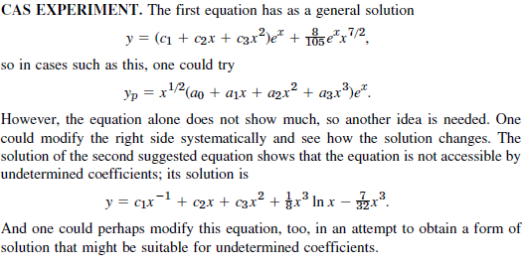

No.15

